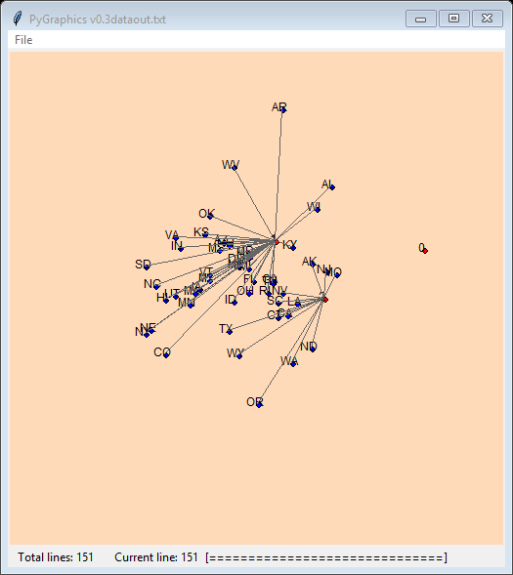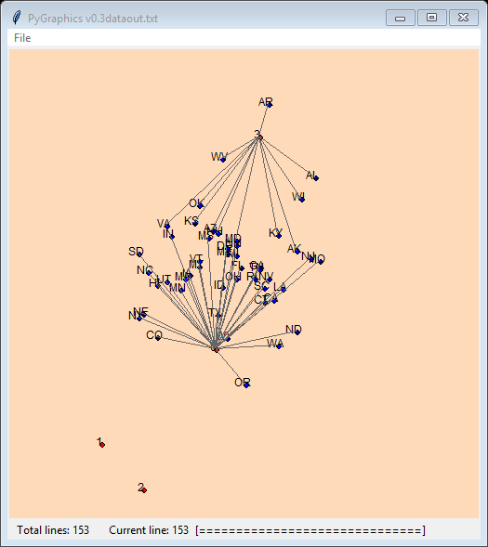

K = 3 K = 4

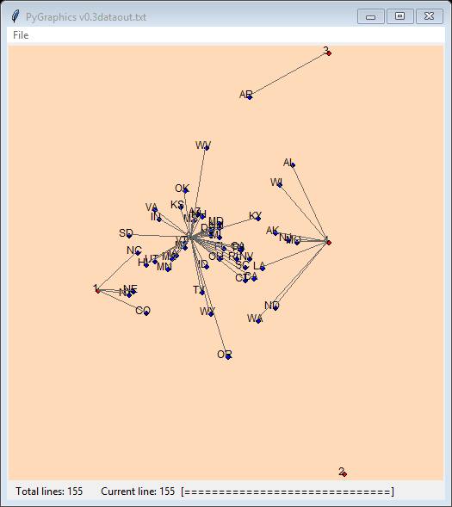

K = 5

Given random beginning points for our centroids the clustering has very little pattern to it, sometimes completely leaving out any given centroid completely as an outlier. The screen caps above show for k=3, 4, 5 respectively. Upon closer inspection, we have found that the recursion is never actually happening, but have been unable to figure out why it is not making more than one iteration.

In theory, the clusters should somewhat “balance” with each other which is unsurprising, but not particularly helpful.